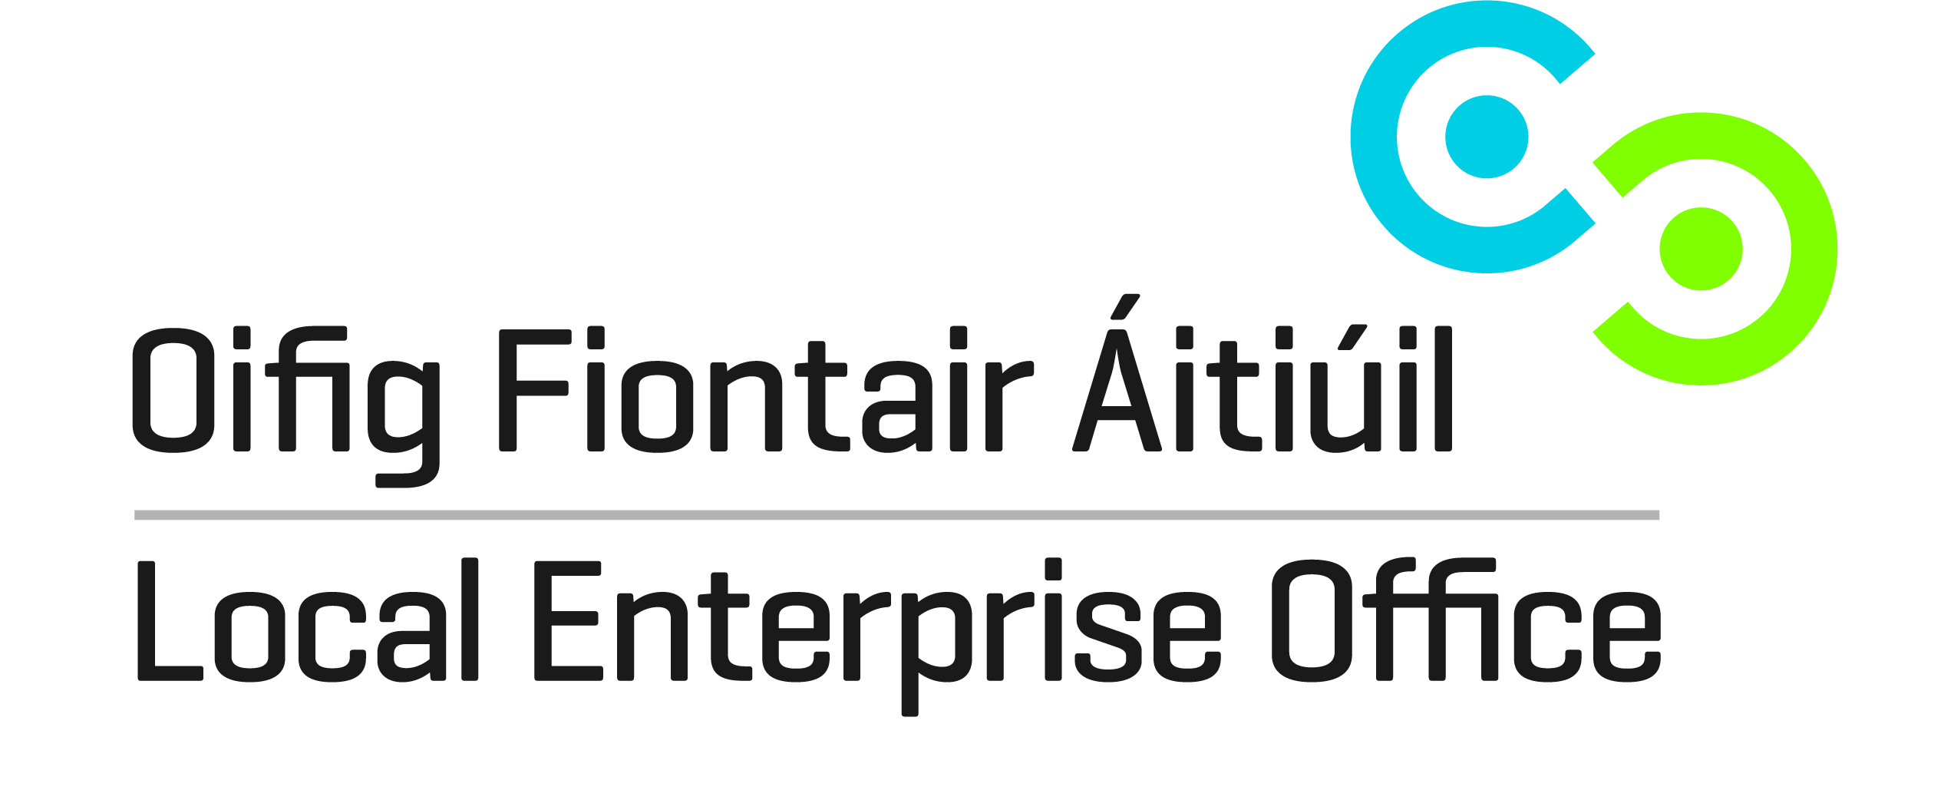

Enterprise & Innovation Workshops 2014
 |  | Mayo
 |  | Contact: Paula Prendergast
 |  | paulaprendergast@leo.mayococo.ie
 |  | 094 904 7555
Is my Craft Product aesthetically & financially viable? |  | 26-May
Facilitator Lorraine Bowen
Product Design & Branding Workshop |  | 15 Sept
Simon Dennehey & Jordan Ralph
Costing & Pricing accurately |  | 22 Sept
Marain Mc Donald Lifeline Business Services or Lorraine Bowen
Branding & PR for my Craft & Design business |  | 29 Sept
Norenn D'Arcy PR & Marketiing & Jordan Ralph Designer
Is my product range export ready? |  | 6 Oct
Lorraine Bowen Designer/ Meabh Ring
Merchandising my product effectively |  | 13 Oct
Eleanor Harpur Visual Merchandsing Expert.
Effective Use of Social Media in promoting my C&D product
Aishling Nielson
FACILITATORS / TRAINERS WILL BE DRAWN FROM DCCoI Design
Panel.

Enterprise & Innovation Workshops 2014
Workshop

Is my Craft Product aesthetically & financially viable?
Facilitator: Lorraine Bowen

WORKSHOP OVERVIEW
This workshop is designed to allow participants to conduct a focused SWOT analysis of their current product offering. As the SWOT analysis will touch on many areas including product design, costing, packaging, production etc. this workshop, as the first in a series, will be tailored to ensure that it does not overlap with following scheduled sessions. It aims instead to highlight issues of concern that can be addressed through future sessions. In the case where CEBs have selected not to run DCCoI workshops on product design, packaging, branding, costing and pricing these areas can be covered in more detail within this workshop to ensure participants are equipped to plan for change in these key areas.

Workshop
Product Design & Branding Workshop
Facilitators: Simon Dennehy, Jordan Ralph

WORKSHOP OVERVIEW
A discovery of cutting edge design in consumer products, furnishing and jewellery and accessories.

Workshop
Costing & Pricing Accurately
Facilitators: Marian McDonald Lifeline Business Services, Lorraine Bowen

WORKSHOP OVERVIEW
This workshop is designed to help participants understand how to determine the accurate cost price and the right selling price for their products and services. It is a practical workshop designed to get existing businesses to reflect and discuss how they currently cost and price their products and services. For new creative start-ups it is an opportunity to understand the factors that affect costing and pricing and to help them decide how best to structure their business model to address those factors. We will examine the real value of what a craft maker brings to their business and ensure that this value is reflected in the price.

Workshop

Branding & PR for my Craft & Design business
Facilitators: Noreen D'Arcy PR & Marketing, Jordan Ralph Designer

WORKSHOP OVERVIEW
Noreen D’Arcy founder of award winning, bi lingual communications company D’Arcy Marketing & PR delivers highly innovative, practical and focused Public Relations Workshops. Her distinctive presentation style showcases the in-depth industry knowledge, media contacts and innovative approach to PR of her company. As a result, participants gain a valuable overview of what’s involved in developing a focused PR campaign that is results driven. Learning how to develop a dedicated media database, design, craft and write a distinctive press release and formulate ideas on how attract media attention for their brand and product while operating on a tight budget are many of the topics covered. Participants will leave energized and ready to embrace PR having engaged in a very interactive workshop that is full of practical tips and know how. Sample Press books and press releases are available for participants to review.

Workshop

Is my product range export ready?
Facilitator: Meabh Ring

WORKSHOP OVERVIEW
This workshop aims to assist participants to fully examine their readiness to begin export activity. It allows them the opportunity to assess their motivations and the reality of their current situation. They will be guided through the strategic export planning process they will need to engage in to realise their export aims. Some participants may come to the understanding that they are not ready to export or that there is perhaps enough untapped potential business in Ireland to meet the production capacity dictated by their business model. It is intended that participants will leave the training session with a clear plan of tasks that need to be completed within a set timeframe to allow them complete their decisions re engaging in export activity.

Workshop

Merchandising my Product Effectively
Facilitator: Eleanor Harpur, Visual Merchandising Expert

WORKSHOP OVERVIEW
Eleanor has worked as an interior stylist and retail consultant in Ireland and abroad for the past 10 years. She held an eight-year in-house position with Habitat Ireland as Creative Art Director and Retail Project Manager. Now freelance, Eleanor is the resident stylist for House & Home magazine and also works on projects ranging from catalogue photography, event styling, exhibition design, retail display, advertising and editorial styling.
Links: http://www.ccoienterprise.ie/ideas/article/sales-strategies

Workshop

Effective Use of Social Media in Promoting my Craft & Design Product
Facilitator: Aisling Nelson

Workshop Overview
Aisling will demystify the jargon and explain how being social online can help your business. Attendees will come away with a greater understanding of the importance of owning your brand and how to communicate with customers and peers online. They will get an overview of the different platforms and which ones best suit their business. The insights gained, will help each business owner to start creating their online marketing plan.

